1. Minimization of Boolean Expression

1.1 Solution for Minimization:

The solution for minimization of a Boolean expression involves two important steps. They are

- Deriving minterms whose disjunction is equivalent to the Boolean expression.

- Obtaining prime implicants from the obtained minterms.

- Deriving minterms from the Boolean expression.

The minterms can be obtained in two ways. They are

  - By deriving the principle disjunctive normal form of the given Boolean expression.
  - By using a simple logic.

- By deriving the principle disjunctive normal form of the given Boolean expression.

In this method we have to use distributive laws, commutative laws, symmetric laws and identities.

This method becomes tedious if the given formula is complicated and contains more than two or three variables.

Hence I am not using this method for the development of my application.

- By using a simple logic.

The logic is for every truth value ‘T’ in the truth table of the given formula, select the minterms which also has the value ‘T’ for the same combination of the truth values of the variables. The disjunction of these minterms will then be equivalent to the given Boolean expression.

I am using this logic to develop my application because it will not become tedious with the increase in number of variables.

- Obtaining prime implicants from the obtained minterms.

Prime implicants can be obtained from the obtained minterms in two ways. They are

  - Karnaugh maps.
  - Cube cover method.

a. Karnaugh maps.

Karnaugh maps can be used only for manual simplification of Boolean expression, it cannot be computerized because there is no good way to represent the function in K- maps if number of variables is greater than six.

b. Cube cover method.

The internal logic of this method is to compute 1- cubes from 0 – cubes and then 2- cubes from 1- cubes and so on until there can be no new covers that can obtained.

I am using this logic in the development of my application for obtaining prime implicants.

1.2 Code:

/* Program to minimize the given Boolean expression */

#include"stdio.h"
#include"ctype.h"
#include"string.h"
#include"math.h"

void main(void)
{
clrscr();

takeinputs();

getminterms();

getprimeimpli();

clrscr();
gotoxy(35,13);printf("Thank U");
getch();
}

char expr[100]=""; /* Array to hold the input expression */
char var[100][10]={""}; /* Array to hold the input variables */
int cou=0; /* Counter to hold the count of the variables */

takeinputs(void)
{
int len; /* Variable to hold the length of the input expression */
int i,j; /* Loop counters */

/* Introduction notes for this application */
gotoxy(23,8);printf("Operations Symbols");
gotoxy(23,10);printf("==========================================");
gotoxy(23,12);printf("AND . ");
gotoxy(23,14);printf("OR + ");
gotoxy(23,16);printf("NEGATION ` ");
gotoxy(23,18);printf("PARANTHESIS ()");
gotoxy(40,24);printf("Press any key to continue . . .");
getch();
clrscr();

/* To take the input from the user */
gotoxy(23,12);printf("Enter the Boolean expression :-> ");
gets(expr);

/* To compute the length of the input expression */
len=strlen(expr);

/* To remove spaces in the expression */
for(i=0;i<len;i++)
if(expr[i] == ' ')
{
j=i;
for(;expr[j] != '\0';j++)
expr[j]=expr[j+1];
len=strlen(expr);
}

/* To separate variables from the expression */
for(i=0;i<len;i++)
{
if(isalnum(expr[i]))
{
char temp[10]="";
temp[0]=expr[i];
temp[1]='\0';
strcat(var[cou],temp);
}

if(expr[i] == '.' || expr[i] == '+')
{
cou++;
}
}

/* To sort the variables */
for(i=0;i<=cou;i++)
for(j=i+1;j<=cou;j++)
if(strcmp(var[i],var[j]) > 0)
{
char temp[10]="";
strcpy(temp,var[i]);
strcpy(var[i],var[j]);
strcpy(var[j],temp);
}

/* To eliminate repetitions */
for(i=0;i<=cou;i++)
{
while(!strcmp(var[i],var[i+1]))
{
for(j=i+1;j<=cou;j++)
strcpy(var[j],var[j+1]);
cou--;
}
}

clrscr();

gotoxy(23,12);printf("No of variables are :-> %d\n",cou+1);

gotoxy(23,14);printf("The Variables are :-> ");
for(i=0;i<=cou;i++)
printf("%s ",var[i]);

gotoxy(40,24);printf("Press any key to continue . . .");
getch();
}

int stack[100]={7}; /* Array to act as a stack */
int st=-1; /* Variable to act as stack top */
int min[100][10]; /* Array to hold the minterms */
int mcou; /* Variable to hold the minterms count */
int andor=0; /* Variable to control the precedence */

getminterms()
{
int max; /* To hold the no of possibilities */
int i,j,k; /* Loop variables */
int inter[100]={7}; /* To hold intermediate result */

max=pow(2,cou+1); /* Total no of possibilities */

clrscr();
gotoxy(15,4);printf("The Truth Table of the Boolean expression is as follows :\n\n\n");
for(i=0;i<=cou;i++)
printf(" %s ",var[i]);
printf("Result \n");

/* To generate minterms */
for(i=0;i<max;i++)
{
int a[10]={0}; /* To hold the binary format */
int temp=i;

andor=0; /* Initialization of precedence controller */

/* To initialize the stack every time */
st=-1;
for(k=0;k<100;k++)
stack[k]=7;

/* To generate binary codes */
for(j=cou;j>=0;j--)
if(temp-pow(2,j) >= 0)
{
a[cou-j]=1;
temp-=pow(2,j);
}

for(k=0;k<=cou;k++)
printf(" %d ",a[k]);

/* To solve the given boolean expression */
for(j=0;j<strlen(expr);j++)
{
char va[10]="";
if(isalnum(expr[j]))
{
/* To seperate variables from the expression*/
for(k=j;isalnum(expr[k]);k++)
{
char te[10]="";
te[0]=expr[k];
te[1]='\0';
strcat(va,te);
}
j=k-1;

/* To place variable inputs behalf of variables */
for(k=0;k<=cou;k++)
if(!strcmp(var[k],va))
if(expr[j+1] == '`')
{
push(nag(a[k]));
j++;
}
else
push(a[k]);
}
else if(expr[j] == '.')
push(2);
else if(expr[j] == '+')
push(3);
else if(expr[j] == '(')
push(4);
else if(expr[j] == ')')
push(5);
else if(expr[j] == '`')
push(6);
}

andor=1; /* Changing the precedence variable */

for(k=0;st != -1;k++)
inter[k]=pop();

for(j=0;j<k;j++)
push(inter[j]);

k=pop();
printf(" %d \n",k);

/*To collect the minterms in to an array */
if(k == 1)
{
for(k=0;k<=cou;k++)
min[mcou][k]=a[k];
mcou++;
}
}
gotoxy(40,24);printf("Press any key to continue . . .");
getch();
clrscr();
gotoxy(15,4);printf("The minterms of the given expression are as follows : \n\n\n");
for(i=0;i<=cou;i++)
printf(" %s ",var[i]);
printf("\n");

for(i=0;i<mcou;i++)
{
for(k=0;k<=cou;k++)
printf(" %d ",min[i][k]);
printf("\n");
}
gotoxy(40,24);printf("Press any key to continue . . .");
getch();
}

/* To perform push operation on the stack and to solve the Boolean expression */
push(int temp)
{
if((temp == 2) || (temp == 3))
{
st++;
stack[st]=temp;
}
else if(temp == 5)
{
if(stack[st-1] == 4 && andor == 0)
{
int z=pop();
pop();
push(z);
return;
}
else
{
st++;
stack[st]=temp;
}
}
else if(temp == 4)
{
if(stack[st-1] == 5 && andor == 1)
{
int z=pop();
pop();
push(z);
return;
}
else
{
st++;
stack[st]=temp;
}
}
else if(stack[st] == 2)
{
int z,y;
pop();
z=pop();
y=and(z,temp);
push(y);
return;
}
else if(stack[st] == 3)
{
if(andor == 1)
{
int z,y;
pop();
z=pop();
y=or(z,temp);
push(y);
return;
}
else
{
st++;
stack[st]=temp;
}
}
else if(temp == 6)
{
if(stack[st] != 5 && andor == 0)
{
int z;
z=pop();
push(nag(z));
}
else
{
st++;
stack[st]=temp;
}
}
else
{
if(stack[st] == 6)
{
pop();
push(nag(temp));
}
else
{
st++;
stack[st]=temp;
}
}
}

/* To perform pop operation on the stack */
pop()
{
int temp;
temp=stack[st];
stack[st]=7;
st--;
return(temp);
}

/* To perform negation operator behavior */
nag(int a)
{
if(a == 1)
return 0;
else
return 1;
}

/* To perform Boolean and function */
and(int a,int b)
{
return(a&b);
}

/* To perform Boolean or function */
or(int a,int b)
{
return(a|b);
}

int cu1[50][10],cu2[50][10]; /* Arrays to hold cubes temporarily */
int in1[50],in2[50]; /* Arrays to hold the indexes of the cubes */
int cou1,cou2; /* Variables to hold the count of the cubes */
int result[50][10]; /* Array to hold the result */
int rc; /* Variable to hold result array counter */
int fresult[50][10]; /* Array to store the final result */
int frc; /* Variable to hold the final result count */

getprimeimpli()
{
int i,j,k,l; /* Loop variables */
int end=0; /* To indicate the end of the process */
int ind; /* To indicate the no of bits diff between two cubes */
int m,n,o,p,ccou=0;

for(cou1=0;cou1<mcou;cou1++)
for(j=0;j<=cou;j++)
cu1[cou1][j]=min[cou1][j];

do
{
/* Initialization of count and index 2 */
for(i=0;i<cou2;i++)
in2[i]=0;
cou2=0;

/* To find the more general term and place it in another array */
for(i=0;i<cou1;i++)
for(j=i+1;j<cou1;j++)
{

for(ind=0,k=0;k<=cou;k++)
{
if(cu1[i][k] != cu1[j][k])
{
ind++;
if(ind == 1)
{
m=i;
n=j;
o=k;
}
}
}

if(ind == 1)
{
in1[m]=1;
in1[n]=1;

for(l=0;l<=cou;l++)
if(l != o)
cu2[cou2][l] = cu1[m][l];
else
cu2[cou2][l] = 2;

cou2++;
}
}

p=0;
for(i=0;i<cou1;i++)
if(in1[i] != 1)
{
p++;

for(j=0;j<=cou;j++)
result[rc][j]=cu1[i][j];
rc++;
}

clrscr();
gotoxy(15,4);printf("The %d cubes of the Boolean expression are as follows : \n",ccou++);
for(i=0;i<=cou;i++)
printf(" %s ",var[i]);
printf("index \n");

for(i=0;i<cou1;i++)
{
for(j=0;j<=cou;j++)
printf(" %d ",cu1[i][j]);
printf(" %d \n",in1[i]);
}

gotoxy(40,24);printf("Press any key to continue . . .");
getch();

if(p == cou1)
{
end = 1;
break;
}

/* Initialization of index 2 */
for(i=0;i<cou1;i++)
in2[i]=0;

/* Initialization of count and index 1 */
for(i=0;i<cou1;i++)
in1[i]=0;
cou1=0;

/* To find the more general term and place it in another array */
for(i=0;i<cou2;i++)
for(j=i+1;j<cou2;j++)
{

for(ind=0,k=0;k<=cou;k++)
{
if(cu2[i][k] != cu2[j][k])
{
ind++;
if(ind == 1)
{
m=i;
n=j;
o=k;
}
}
}

if(ind == 1)
{
in2[m]=1;
in2[n]=1;

for(l=0;l<=cou;l++)
if(l != o)
cu1[cou1][l] = cu2[m][l];
else
cu1[cou1][l] = 2;

cou1++;
}
}

p=0;
for(i=0;i<cou2;i++)
if(in2[i] != 1)
{
p++;

for(j=0;j<=cou;j++)
result[rc][j]=cu2[i][j];
rc++;
}

clrscr();
gotoxy(15,4);printf("The %d cubes of the Boolean expression are as follows : \n",ccou++);
for(i=0;i<=cou;i++)
printf(" %s ",var[i]);
printf("index \n");

for(i=0;i<cou2;i++)
{
for(j=0;j<=cou;j++)
printf(" %d ",cu2[i][j]);
printf(" %d \n",in2[i]);
}

gotoxy(40,24);printf("Press any key to continue . . .");
getch();

if(p == cou2)
{
end = 1;
break;
}

/* Initialization of index 1 */
for(i=0;i<cou1;i++)
in1[i]=0;
}
while(end == 0);

/* To eliminate repetitions in the obtained prime implicants */
for(i=0;i<rc;i++)
{
m=0;
for(j=i+1;j<rc;j++)
{
for(ind=0,k=0;k<=cou;k++)
if(result[i][k] == result[j][k])
ind++;

if(ind > cou)
m++;
}

if(m == 0)
{
for(l=0;l<=cou;l++)
fresult[frc][l] = result[i][l];
frc++;
}
}

/* To print the prime implicants on the screen */
clrscr();
gotoxy(15,4);printf("The prime implicants of the Boolean expression are as follows : \n",ccou++);
for(i=0;i<=cou;i++)
printf(" %s ",var[i]);
printf("\n");

for(i=0;i<frc;i++)
{
for(j=0;j<=cou;j++)
printf(" %d ",fresult[i][j]);
printf("\n");
}

gotoxy(40,24);printf("Press any key to continue . . .");
getch();

/* To generate the minimized expression */
clrscr();
gotoxy(15,4);printf("The minimized expression is :-> ");

for(i=0;i<frc;i++)
{
for(j=0;j<=cou;j++)
{
if(fresult[i][j] == 1)
printf(" %s",var[j]);
else if(fresult[i][j] == 0)
printf(" %s`",var[j]);
}

if(i < frc-1)
printf(" + ");
}

gotoxy(40,24);printf("Press any key to continue . . .");
getch();
}

1.3 Output:

Screen: 1

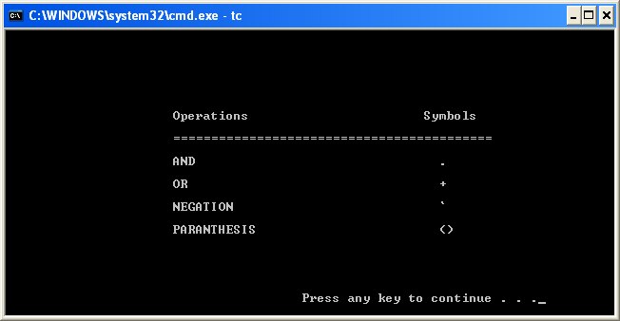

Screen: 2

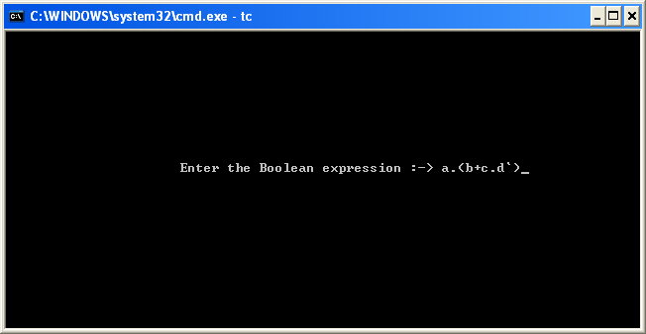

Screen: 3

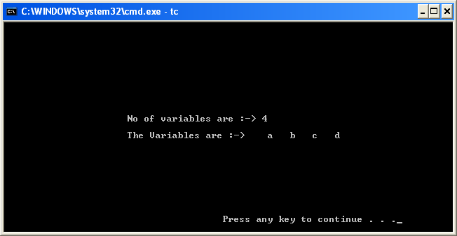

Screen: 4

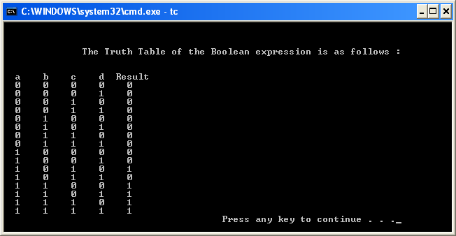

Screen: 5

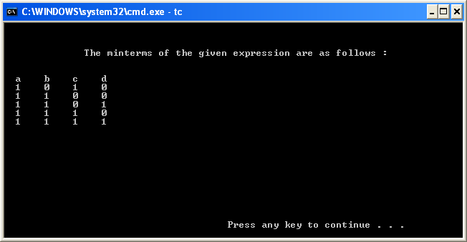

Screen: 6

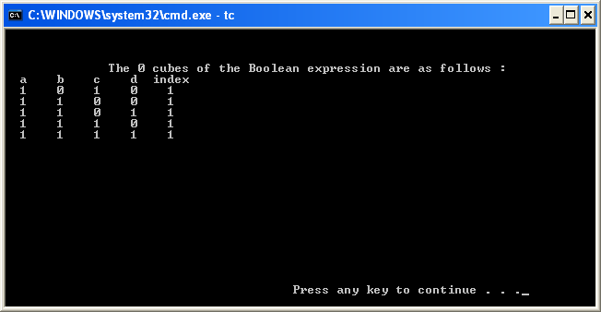

Screen: 7

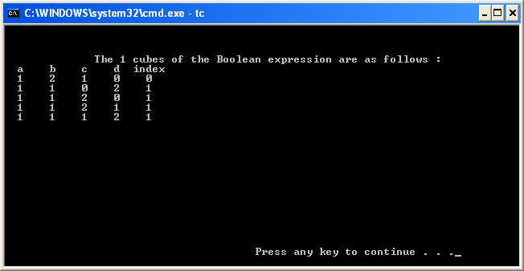

Screen: 8

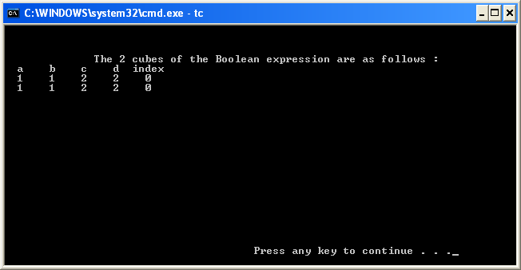

Screen: 9

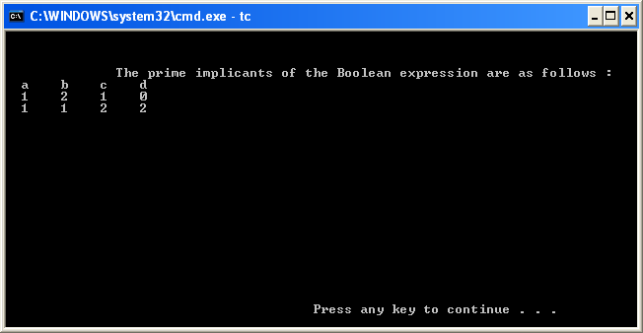

Screen: 10

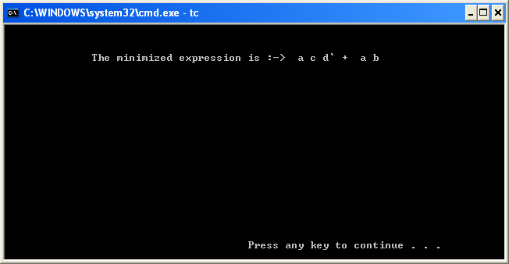

Screen: 11

